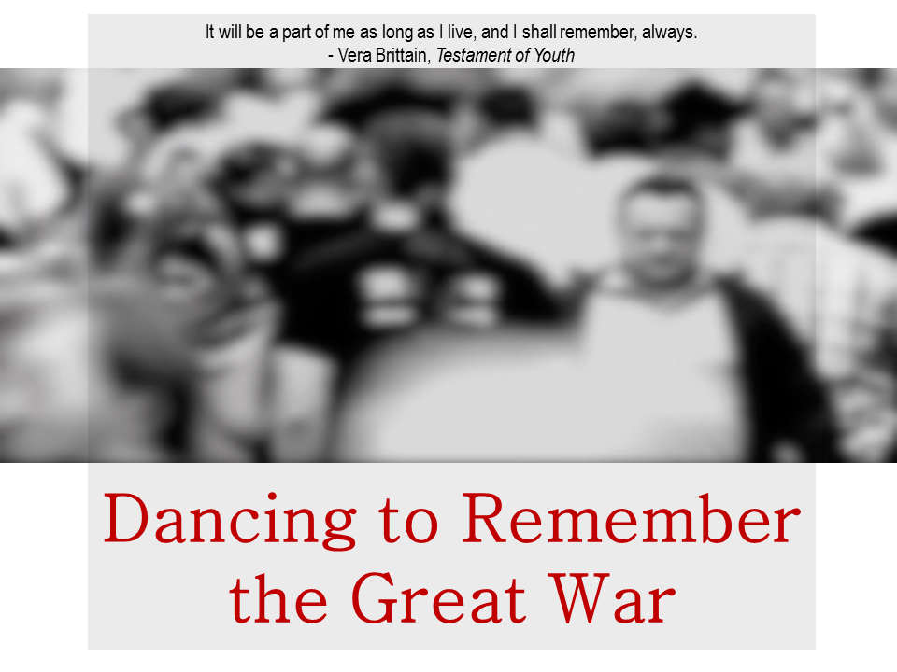
The second year Dance degree module, Choreolab, gives students the chance to explore the intersection of live dance performance and film. This year the creative stimulus for their explorations was the artistic, intellectual, and thematic preoccupations of the Great War era. The challenge for the students was both finding a response to this historical period that speaks to the depth and complexity of this time and making a contemporary piece of art that is relevant for today’s audience. To help them explore, the class went to the Imperial War Museum North in Salford where they visited both the main exhibition space as well as the museum’s special exhibition looking at the North West during the conflict. In addition the creative pieces have been realised by the students through implementing the award-winning real-time media manipulation software ISADORA.
Please join us for an evening of stimulating original performance work.
The Performance Hub, University of Wolverhampton, Walsall Campus
Magdalene Rd
WS1 Walsall
United Kingdom
3pm Thursday 22 January – Invited Dress Rehearsal
7:30pm Thursday 22 January – Performance
7:30pm Friday 23 January – Performance
Tickets available at: http://www.eventbrite.co.uk/e/dancing-to-remember-the-great-war-tickets-15005734556?aff=eac2
For further information please contact: Karen Wood Karen.Wood@wlv.ac.uk or Victoria Thoms vickithoms@wlv.ac.uk

