FAITH AND THE FIRST WORLD WAR
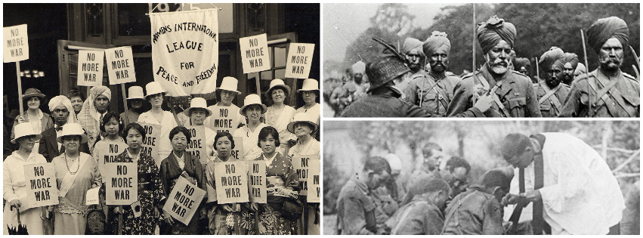
Conference: UNIVERSITY OF GLASGOW, 21-22 JULY 2016
Plus: A programme of events to mark the centenary of the Women’s Peace Crusade
23 JULY 2016 at GLASGOW WOMEN’S LIBRARY
Please complete the form below and return it by 31 May 2016 to: Dr Charlotte Methuen, Theology and Religious Studies, No. 4 The Square, University of Glasgow, Glasgow, G12 8QQ (e-mail: charlotte.methuen@glasgow.ac.uk).
Cheques should be made out to “The University of Glasgow”. Bookings may also be made via Eventbrite: visit (https://www.eventbrite.com/e/faith-and-the-first-world-war-tickets-24680348587). Cost to participants is £25.00 per day to include coffees, teas and lunch. Cheques should be made out to “The University of Glasgow” or payment may be made by cash on registration. We can provide a list of local and university accommodation.

Name: Affiliation:

Address:

E-mail:
Emergency contact: name telephone number:

 |  | amount
1. | Conference attendance on 21 July (£25.00, or £15.00 concessions)
2. | Conference attendance on 22 July (£25.00, or £15.00 concessions)
3. | Commemoration of the Women’s Peace Crusade on 23 July
I enclose a cheque / I will pay by on registration
(please delete as appropriate) Total
4. | I have the following special needs for diet / room access:
5. | I wish to offer a communication at the Conference, entitled:  Please also complete the next page of the form
Please tick if you do NOT wish your e-mail address to appear on the list of participants O

Signed: Date:
For those offering a communication at the conference:

1. | Title of communication
2. | Abstract (100-150 words – this will be made available to conference participants)
3. | I require the following audiovisual / projection equipment

Please submit this form electronically to charlotte.methuen@glasgow.ac.uk by 31 May 2016.

