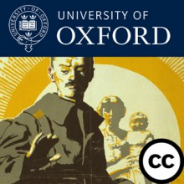
Share your WW1 research with an international audience
Do you work with material related to the First World War? Are you interested in engaging a wider audience with your ideas? Would you like to gain experience for your CV and show that you can communicate effectively to the public? As part of the University’s World War One Centenary activities, TORCH has teamed up with Academic IT Services to launch a WW1 Research competition.
We welcome proposals from students and early career researchers, from any discipline, to present new perspectives on the War and its impact through either a blog post or short (audio/video) podcast. We also welcome proposals from college, library and museum staff that tell a story of the University in WW1. We will support selected entries to develop their digital content which will then be featured on some of the University’s global channels, including the world-famous Oxford iTunesU, Podcasts.ox.ac.uk, the Oxford Centenary Programme and World War One Centenary: Continuations and Beginnings websites.
The awards will be judged by a panel of specialists on the First World War and public engagement. Prizes will include an iPad Mini and the exciting opportunity to network with experts at the 2016 International Society for First World War Studies conference.
To find out more about the competition and how to take part, please read our competition guidelines and contact ww1collections@it.ox.ac.uk if you have any further questions. Submit your entry via ‘Oxford Ideas’ by midnight on August 1st 2016. Good luck!

