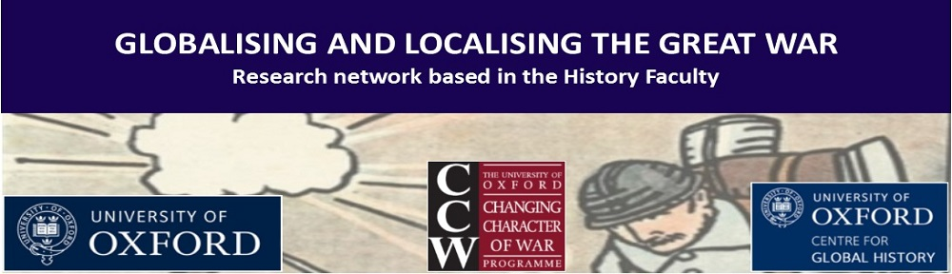

Globalising and Localising the Great War Seminar Series

Room: Memorial Room, Worcester College, 16.00

Hilary Term

Week 1 (Jan 19)

Week 2 (Jan 26) – Dr Arabella Hobbs (University of Pennsylvania) ‘Enmity or empathy? Jacques Rivière’s L’Allemand’

Week 3 (Feb 2) – Professor Alexander Watson (Goldsmith’s University) ‘The Fortress: A Case Study of Total War in the East, 1914-15’

Week 4 (Feb 9)

Week 5 (Feb 16)

Week 6 (Feb 23) – Dr Jonathan Boff (University of Birmingham) ‘Ego-Documents and Official History: Crown Prince Rupprecht of Bavaria's Diary and the Battle for Memory, 1914-39’

Week 7 (Mar 2) – Dr Maggie Andrews (University of Worcester) ‘Worcestershire's Women: local studies and the gender politics of the Great War and its legacy’

Week 8 (Mar 9) – Dr Jessica Meyer (Leeds) ‘From Bandage Wallahs to Knights of the Red Cross: The Men of the Royal Army Medical Corps in the First World War’

