The Fictional First World War: Imagination and Memory Since 1914
An International Conference at the Centre for the Novel
Sir Duncan Rice Library, University of Aberdeen, 6-9 April 2017
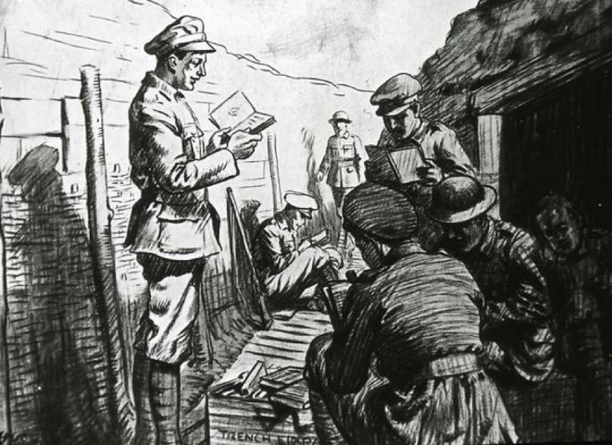
Plenary Speakers: Oliver Kohns, University of Luxembourg; Randall Stevenson, University of Edinburgh; and Steven Trout, University of South Alabama
The First World War was a very real event. However, since August 1914, authors have been writing their own versions of it. During the war, novels and short stories shaped public opinion about the conflict. After its close, fiction became a means of recalling and re-examining events. The war was ‘fictional’ in other ways too. Many supposedly truthful accounts of the war, whether in newspaper reports or in personal memoirs, were not as factual as they seemed. Wartime writing in combatant nations was heavily censored; post-war writing was often flawed by the passing of time and the experience of trauma. So, while the war of 1914-18 is often recalled through poetry, the fictions of the war offer challenging perspectives, and raise powerful questions about experience and art.
This international conference, hosted by the Centre for the Novel, invites intercultural dialogue about the war’s aesthetic and intellectual legacy. With plenary speakers exploring British, German and American material, this event explores how war narratives are able to disrupt critical categories and to defy national boundaries—but also to entrench them. It examines how factual writing about the war, including Government sponsored ‘propaganda’ materials, adopted the techniques of fiction to energize the emotional case for conflict. It also looks at how war fiction interacts with other genres and media. Timed to coincide with the centenary of the US entry to the First World War on 6 April 1917, this event will also ask what it means to think about the war beyond national contexts.
Panels might include: Autobiographies of War; Writing and Nationalism; Trench Narratives; Nursing Narratives; Home Front Fiction; Transnational Fiction of the First World War; Memoirs and Fiction; Post-war novels and stories; War Fiction and Theatre; Music and War Fiction; Authenticity; Reading in Wartime; Publishing Practices; What is Propaganda?; War Crime Writing; Children’s Literature; WWI in Contemporary Fiction; WWI and the Critics; Warscapes; Coming Home; Letters and Diaries.
English will be the main language of the conference, but papers in other languages may be arranged.
Proposals for panels and individual papers are invited by Friday 16 December 2016. Please send to the Conference Chair: Professor Hazel Hutchison, University of Aberdeen: h.hutchison@abdn.ac.uk More information at: http://www.abdn.ac.uk/sll/research/centre-for-the-novel-215.php
Confirmed participants: William Blazek (Liverpool Hope), Alison Fell (Leeds), Christine Hallett (Manchester), Margaret Higonnet (Connecticut), Karsten Piep (Union Institute and University), Mhairi Pooler (Aberdeen), Jane Potter (Oxford Brookes), Angela K. Smith (Plymouth), Samantha Walton (Bath Spa University).

