

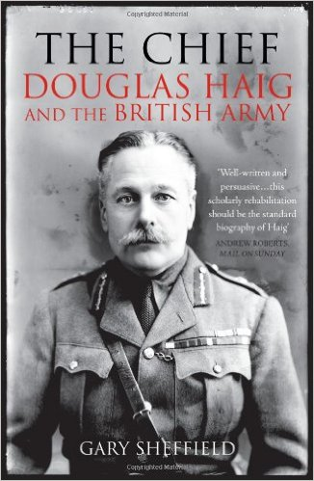

**The Chief: Douglas Haig and the British Army**

**5:30pm, Tuesday 8th November**

**LWA, Wolfson College**



**This event is free of charge and open to all**

**Email: oclw@wolfson.ox.ac.uk**

**Twitter: @OxLifeWriting**

**Visit: www.wolfson.ox.ac.uk/oclw**

**Gary Sheffield**