HISTORY OF WAR SEMINAR SERIES
Michaelmas Term 2017-18
All events take place on Wednesdays 5.15, Wharton Room, All Souls College

ALL WELCOME!

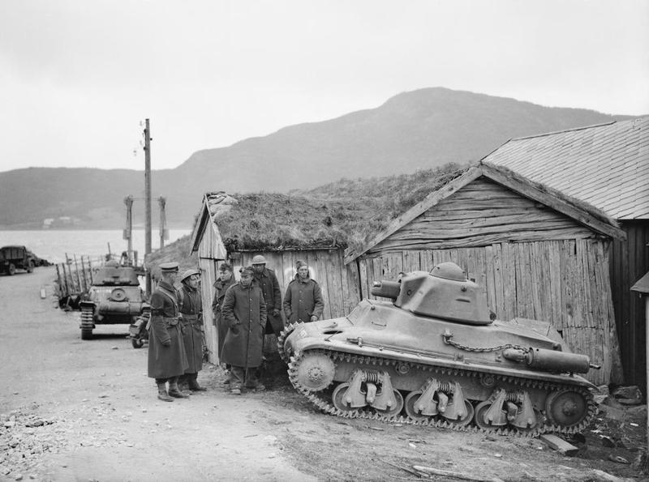

Week 2 18 October
Sir John Kiszely
The British Fiasco in Norway 1940

Week 4 1 November
Pepijn Brandon (International Institute of Social History, NL) tbc

Week 6 15 November
John Horne (Trinity College Dublin)
Occupation and Empire: The Global Dynamics of the Illiberal Wartime State during the First World War
(Joint Session with the Globalising and Localising the Great War Series)

Week 8 29 November
Mary Lindemann (Miami)
Rebuilding Landscapes, Reconstructing Lives: Brandenburg after the Thirty Years War

Convenors
Erica.charters@history.ox.ac.uk
Adrian.gregory@history.ox.ac.uk
Marianne.klerk@history.ox.ac.uk
Peter.wilson@history.ox.ac.uk

