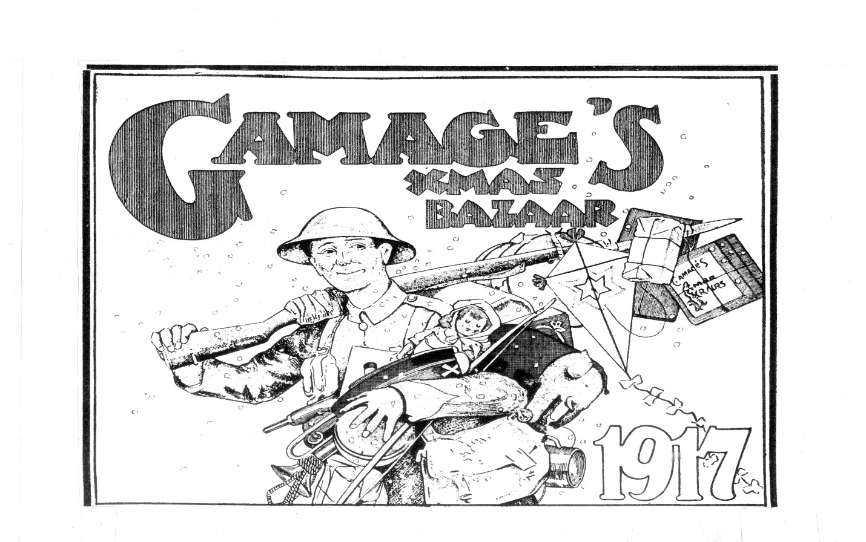

‘Business As Usual and Unusual: Commercial Advertising During The Great War".
Andrew McCarthy

Wednesday 1st November, 5.30-6.30
Pichette Auditorium
Pembroke College

