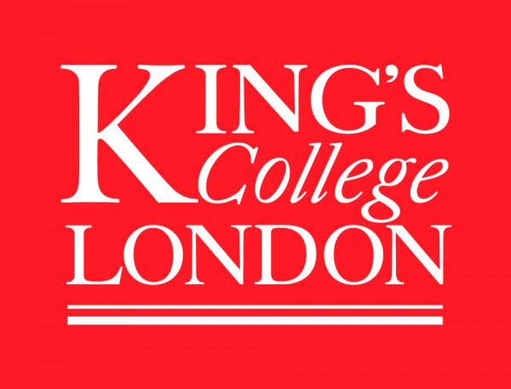
Sir Michael Howard Centre
for the history of war

Seminar series, 2018
Strand Campus, room S8.08
17.15

13 Feb: Ripples in the Sand: the Great War in the Sahara – Jonathan Krause (KCL) – in the Pyramid Room, K4U.04

27 Feb: Did Louis IX read Vegetius? New perspectives on the battle of Taillebourg (1242)
– Amicie Pélissié du Rausas (Université de Poitiers)

13 March: Manpower and State Power in Eighteenth-century Wars – Erica Charters (University of Oxford)

27 March: 'He Don't Mean To Fight You He Only Means To Kill You': The Significance of the Victorio Campaign 1877- 1881 – Robert Watt (University of Birmingham)

For security reasons all outside guests should please RSVP ahead of time at: https://www.kcl.ac.uk/sspp/departments/warstudies/events/index.aspx

